ÇANKAYA UNIVERSITY

Software Requirements Specification

AI CUSTOMER SUPPORT SYSTEM

Alperen Sarınay, Arınç Alp Eren, M. Atakan Demircioğlu, M. Cavid Aydın

**10.11.2019**

**1 Introduction**

**1.1 Purpose and Scope**

This document is a software requirement feature for the web application ai customer support project. Main purpose of this document is to give detailed information about the functionalities, constraints and software requirements of the project. The purpose of this document to describe our project, AI Customer Support. The main objective of the project is a system developed to provide faster and more reliable answers to the questions asked in the support parts of e-commerce sites on web platforms. AI Customer Support is a web system that can be installed on any website. In our system, we will be creating a customer support system which is machine learning based program that can train itself according to the questions asked and also answers given by the non-machine (human) supporters. For each website, our program will use its own data set on the computer where it is installed. If there is no data set on the computer, our system will create its own data set for each question asked and the correct answer after installation. For every solved issue which means question and its’ true answers at the end (does not matter how many questions asked and true or false answers given between these two), machine learning program will create a model and after a while it will start answering questions instead of non-machine supporters.

**1.2 Glossary**

**Term** **Definitions**

|  |  |
| --- | --- |
| CRM | *Customer Relationship Management  * CRM is a technology that allow you to manage your company’s relationship and interactions between customers. |
| AI | * Artificial Intelligence |
| Machine Learning | * Machine learning is an application of that provides systems the ability to automatically learn and improve from experience without being explicitly programmed. |
| Dataset | * Set of data that is grouped under titles. |
| Text Analysis | * Efficient way to turn words into a well dataset. |

**2 Overall Description**

**2.1 Product Perspective**

AI Customer Support project is CRM-like system that any E-Commerce based company and business can use it. Our system will have 2 seperate parts. First part is frequently asked questions (FAQ) which is group of questions and answers that are created by admins and also AI itself. Second part is forum that customers can ask questions. These questions can be answered by admins and also with AI system. But because our AI system is machine learning based system, companies must train it. After enough training, AI system will work and answer questions by itself.

**2.2 Memory Constraints**

AI Customer Support will require at least 1 CPU, 3GB Ram and minimum 15GB space.

**2.3 Operations**

Customers can do several operations on our system. Customers can search for asked questions, which is FAQ, from search bar so they can easily find a solution if the problem already solved. Also customers can share their problems with comunity and create an issue at Forum part. These problems can solved by admins or AI system. After the answers given by admin or AI system, customers should decide whether the solution is true or false. This operation is needed for machine learning training.

On the other hand, if customers decide that the solution is wrong, admins will be notified about this issue so they will solve the problem instead of AI system.

**2.4 Site Adaptation Requirements**

Companies must have a website and a domain to use our system. The only thing companies must do is to drag our files to their original website files.

**2.5 Product Functions**

AI Customer Support system will have 4 different parts. This parts are Profile, Homepage (All Questions), Question and Sign Up.

**Profile**

* Notification button located on the page navigation bar will open a Pop-Up box that show all the notifications, also user can click on them and will be redirected to the related page.
* With Activity button, user can see all questions they asked before and also by clicking on questions, they can go to the question page.
* Edit Profile button will lead user to the profile options page so they can change their informations like password, email, nickname, profile picture etc.

**Use Case Diagram for Profile Page**

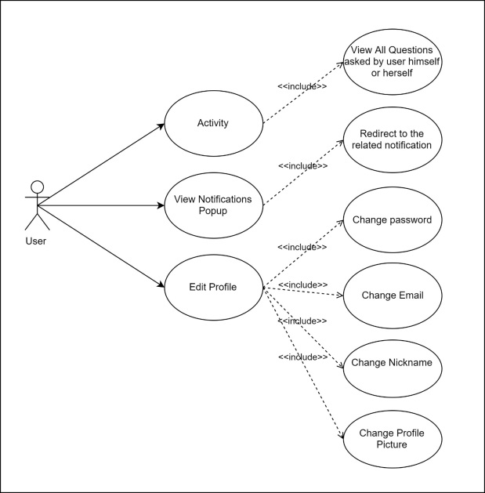

**Homepage (All Questions)**

* Users can input keywords on search box and find their problem if it asked before instead of asking a new questions.
* Filters can be applied on search to make it easy to find the exact problem.
* Time Filters are used to show all question asked since last day, week, month or year.
* Score Filters will sort all questions according to their score in ascending or descending order.
* View Filters will sort all questions according to their view counts in ascending or descending order.
* Show only FAQ Filter will show only Frequently Asked Questions which are created by company owners.
* With Ask Question Button users will be redirected to the page that users can create a question just like on the forum pages. Asked questions won’t be available until it’s marked as “resolved” by user itself. (see Question part)
* By clicking on the question, users will be redirected to the question page.

**Homepage (All Questions) Use Case Diagram**

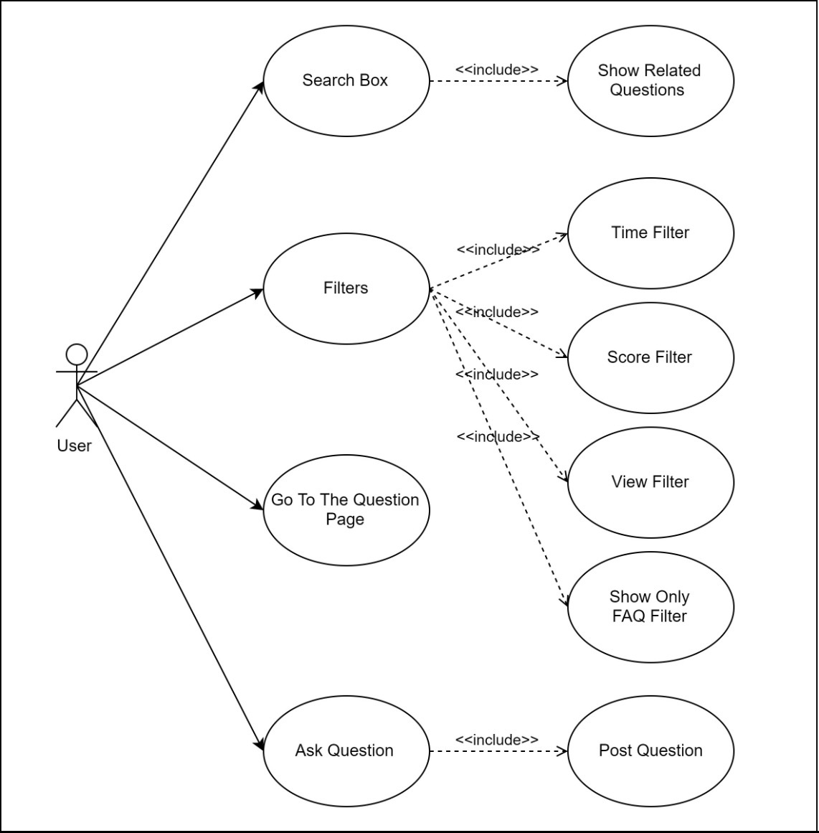

**Question**

* With question voting system, we aim to create a system to create high scored questions so common problems can be found easily by users. Although questions can be voted by users, answers can’t be voted because no answer can be published until it’s fully solved. Because all the answers must be %100 accurate, voting the answers would be meaningless.
* Questions can be answered by only real supporters or AI system.
* Users must verify the answer as “resolved” or “unsolved” so that machine learning can train itself according to accuracy of the answer. Question and related answer won’t be published until users confirm the answer as “resolved” so wrong solutions will not be available in our system.

**Question Use Case Diagram**

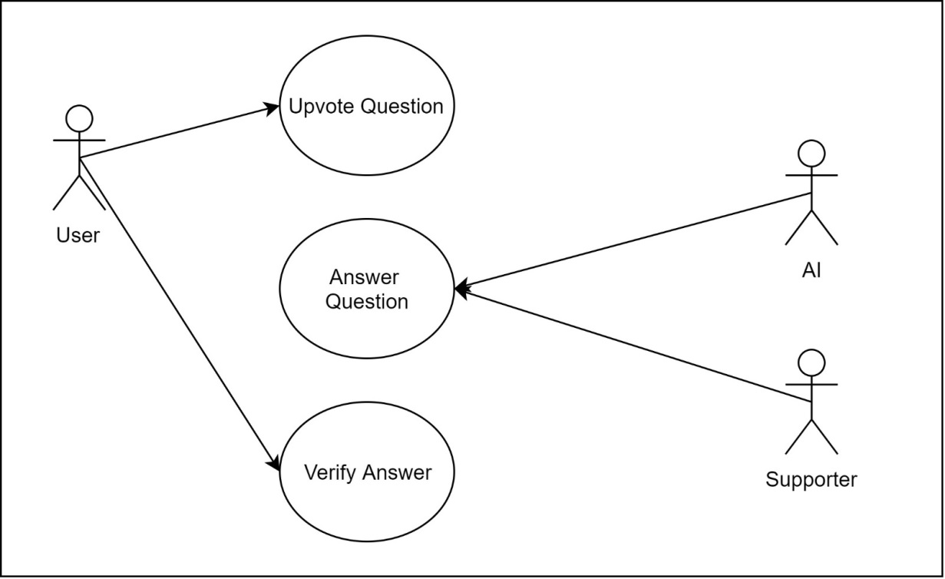

**Sign Up**

* To vote and ask question, users must sign up on our system. On sign up page, users must specify their informations such as name, surname, email, password etc.

**Sign Up Use Case Diagram**

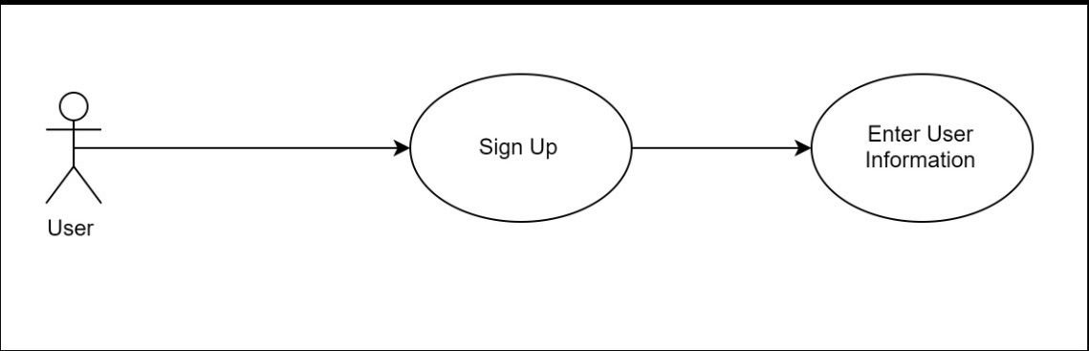

**2.6 User Characteristics**

Because of our system designed for English questions and answers, customers and companies should understand English language.

**2.7 Constraints**

Our system designed for E-Commerce related customer problems with language of English. So any other topics and languages are not supported. Any website that meets these requirements can use our system.

**2.8 Assumptions and Dependencies**

Company website must have PHP on their machine to run our system.

**3 Specification of Requirements**

**3.1 External Interface Requirements**

**3.1.1 User Interfaces**

Our system is a web project and it will have a responsive UI suitable for all platforms. For this we will use bootsrap in the project.

#### 3.1.2 Hardware Interfaces

#### For install the system; user must have a host and probably a domain name. Host must have this system requiretments;

* Minimum 1 CPU
* Minimum 1 GB of RAM
* Minimum 15 GB Space
* Ethernet

#### 3.1.3 Software Interfaces

Any device that (have browser to access internet) can access the website is sufficient to use the system. For install the support System we recommend host supports;

* PHP version 7.3 or greater then this version.
* Linux Or Ubuntu OS
* MySql 5.6 or greater
* HTTPS support (for SSL).

#### 3.1.4 Communications Interfaces

User need a web browser to connect website. For this reason firstly must have internet connection.

#### 3.1.5 Performance Requirements

The most important thing in web-based systems is of course the internet connection. It is also very important that the server can respond to different requests at the same time. For his reason, we will test our software with Apache AB Test before launching. Also we recommend users must test their servers after install our software.

**3.2 Software System Attributes**

**3.2.1 Portability**

* AI Customer Support will use PHP, Javascript and Phyton. So, our project will be available at all platforms like Mobile Phones, Tablets and PCs.
* The system is a web based project and it not require different hardwares for users. But who installs the software must have a basic host.
* All computers and phones will be avaible to use our system.

**3.2.2 Performance**

* Good internet connection is important. Especially the power of the internet where the server is located is very important. Must be fiber. It may be wise to use more than one machine in a wide range of applications, or to separate machines for a database.
* User must have a server that can handle multiple users and multiple requests. For this we have suggested some system requirements above.

#### 3.2.3 Adaptability

#### In the system we have designed, companies will start to keep all the questions asked in their data base as soon as they download AI Customer Support system and adapt it to their website.

#### 3.2.4 Safety Requirements

Since we design a system where customers can easily access everything and receive feedback, it will not cause any inconvenience for our users.

**4 Planning**

**4.1 Team Structure**

Team Members: Alperen Sarınay, Arınç Alp Eren, M. Atakan Demircioğlu, M. Cavid Aydın.

**Task** **Member**

|  |  |
| --- | --- |
| Web Front-End | Alperen Sarınay – M. Atakan Demircioğlu |
| Web Back-End | M. Atakan Demircioğlu – M. Cavid Aydın |
| UI design | Alperen Sarınay – Arınç Alp Eren |
| Machine Learning | Arınç Alp Eren – M. Cavid Aydın |
| Artificial Intelligence (AI) | Alperen Sarınay – M.Atakan Demircioğlu |
| Dataset Manupilation | M. Cavid Aydın – Arınç Alp Eren |
| Advertisement – Seo | M. Atakan Demircioğlu |

**4.2 Estimation**

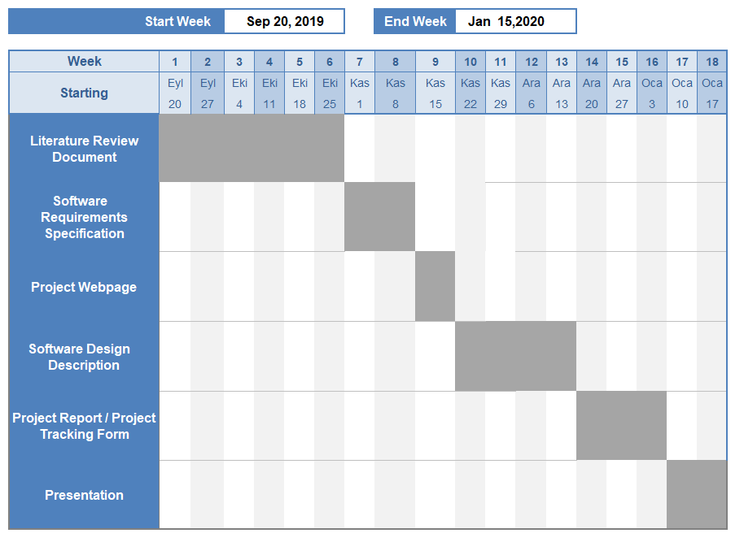

**5 Conclusion**

This software document is intended to explain the details, system and hardware requirements of the AI Customer Support system. At the same time, the project we developed will not only be an idea, but also better planning with the models. With the help of our SRS documentation, it will be more easier to implement and use our system on your website.